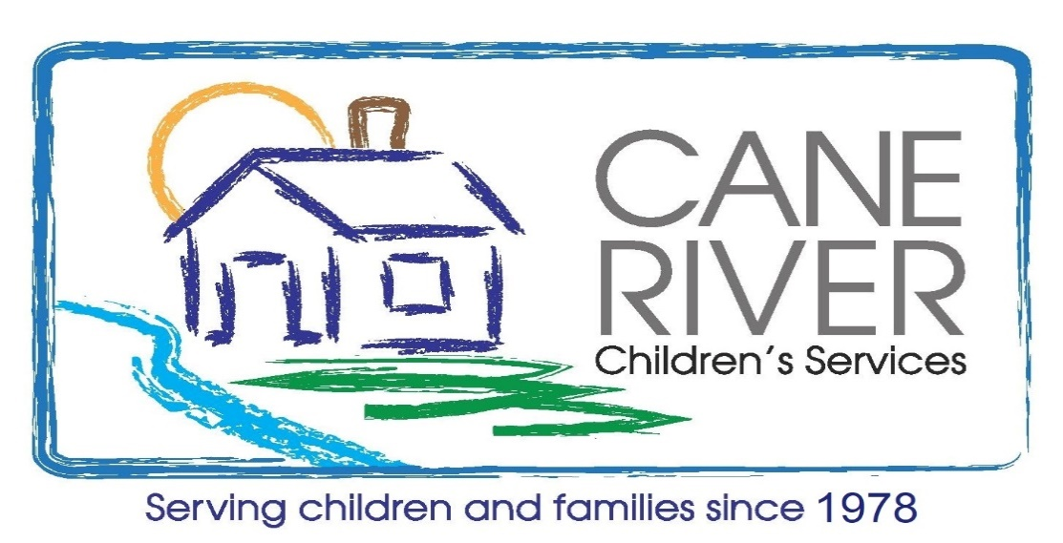
Join us to Stop Child Abuse with
CLAY
TARGETS
FUNDRAISER

1st ANNUAL BIG LOVE CHARITY SHOOT
Date: Saturday, August 26, 2023 Registration: 8:00 AM
Shooting Begins 8:30 AM Lunch and Awards 12:00 PM
Where: | Natchitoches Shooting Range  652 Tauzin Island Road, Natchitoches, Louisiana 71457  (318) 356-9457
What: | A fun-filled day of competition shooting, fellowship, great food, raffles, and prizes.
Participation: | Teams of 4 or individual shooters. Put your own team of 4 shooters together or come out and be matched up with other shooters to form your own team the day of the event. You will shoot with your team at all stations. Individual and team scores will be tracked.
Cost: $100 per individual shooter Corporate, Business and Individual Sponsors
$400 per Team of 4 *$2500 *$1000 *$500*$250
Registration Nolton Causey—318-663-4964 Lennie Shankle—318-471-3054
Contacts: Billy Ebarb— 318-451-0747 Vicki Parrish—318-352-5866

REGISTRATION FORM
Your Name: ________________________________________ Individual ____($100) Team of 4 _____($400)
Address: _________________________________________________________________________________
Phone: ________________________________Email address: _______________________________________
Team Name : ___________________________________________________________________________
Team Members: 1_______________ 2__________________ 3.___________________ 4.__________________

